**

*A project report on*

*Review3*

*E-Learning System*

*Submitted towards Jth component of the course*

*Database Management Systems*

*By*

*Kaki Zohan Areeb(19BCA0006)*

*Satyam(19BCA0041)*

*Manish Pandey(19BCA0058)*

*Introduction*

* 1. Abstract of the Project E-learning Management system:

E-learning is one of the most important and vital ways of

learning these days, which plays an important role in

creating an interactive environment for every person who is

experienced and trained wherever it is and whenever. The

educational platform provides the environment for

exchanging information more easily and quickly by using

presentations, For Beginners (trainees). The Iraqi Ministry

of Higher Education has always been stimulating the

development and establishment of e-learning platforms to be

incorporated and used in Iraqi education systems. The

Internet and powerful worldwide interchanges have

predominantly changed how people approach data. The

present age of students is experiencing childhood in the

advanced condition with PCs, tablets, broadband speed,

remote availability, mobiles telephones, iPods, and different

apparatuses and progressively, more it moves toward

becoming parts of their lives, and it doesn't stop here

however their life subjects turn out to be additionally

digitized and are influenced accessible through this every

day to up and coming computerized gadgets, and data is

accessible anyplace and whenever on any point possible.

The present learning approaches utilized by schools in the

extraordinary inverse with how they learn and connect

outside of the classroom .

E-learning confides in current data and correspondence

advancements for distribution of learning substance.

Learning procedure or its feeling is sorted out as per either

synchronous or asynchronous. Elearning, which has been

developed as a learning solution, represents the distance

education with the flexibility of educational software and

process covering synthesis of different technologies.

1.2 Scope of the project &learning Management System:

It may help collecting perfect management in details. In a very short time, the collection will be obvious, simple and sensible. It will help a person to know the management of passed year perfectly and vividly. It also helps in current all works relative to E-learning Management System. It will be also reduced the cost of collecting the management & collection procedure will go on smoothly.

Our project aims at Business process automation, i.e. we have tried to computerize various processes of &learning Management System.

**The system generates types of information that *can* be used for various Purposes:**

1. It satisfy the user requirement
2. Be easy to understand by the user and operator
3. Be easy to operate Have a good user interface
4. Be expandable
5. Delivered on schedule within the budges.

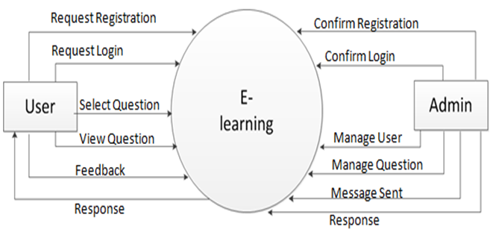

Registration Table

|  |  |  |  |  |
| --- | --- | --- | --- | --- |
| **Sr No** | **Field Name** | **Field Type** | **Field Size** | **Constraints** |
| 1 | User_Id | Int | 06 | A.I/P.K |
| 2 | Name | Varchar | 20 | Not  Null |
| 3 | Address | Varchar | 50 | Not  Null |
| 4 | Country | Varchar | 25 | Not  Null |
| 5 | Email | Varchar | 30 | Is_Unique |
| 6 | Password | Varchar | 20 | Not  Null |
| 7 | Birth date | Date | 30 | Not  Null |
| 8 | Gender | Varchar | 6 | Not Null |
| 9 | Pincode | Int | 6 | Not  Null |
| 10 | Mobile | Varchar | 10 | Not  Null |

User Login Table

|  |  |  |  |  |
| --- | --- | --- | --- | --- |
| **Sr. no** | **Field Name** | **Field Type** | **Field Size** | **Constraints** |
| 1 | User_Id | Int | 6 | A.I/P.K |
| 2 | Email | Varchar | 30 | Not Null |
| 3 | Password | Varchar | 20 | Not Null |

Feedback Table

|  |  |  |  |  |
| --- | --- | --- | --- | --- |
| **Sr. no** | **Field Name** | **Field Type** | **Field Size** | **Constraints** |
| 1 | Id | Int | 6 | A.I/P.K |
| 2 | Name | Varchar | 20 | Not Null |
| 3 | Email | Varchar | 30 | Not Null |
| 4 | Comment | Text | 20 | Not Null |

Relational Database Management System (RDBMS):

This is an RDBMS based project which is currently using MYSQL for all the transaction statement. MYSQL is an open source RDBMS system.

Brief introduction about RDBMS :

**RDBMS** stands for relational database management system. A relational model can be represented as a table of rows and columns. A relational database has following major components:  
1. Table  
2. Record or Tuple  
3. Field or Column name or Attribute  
4. Domain  
5. Instance  
6. Schema  
7. Keys

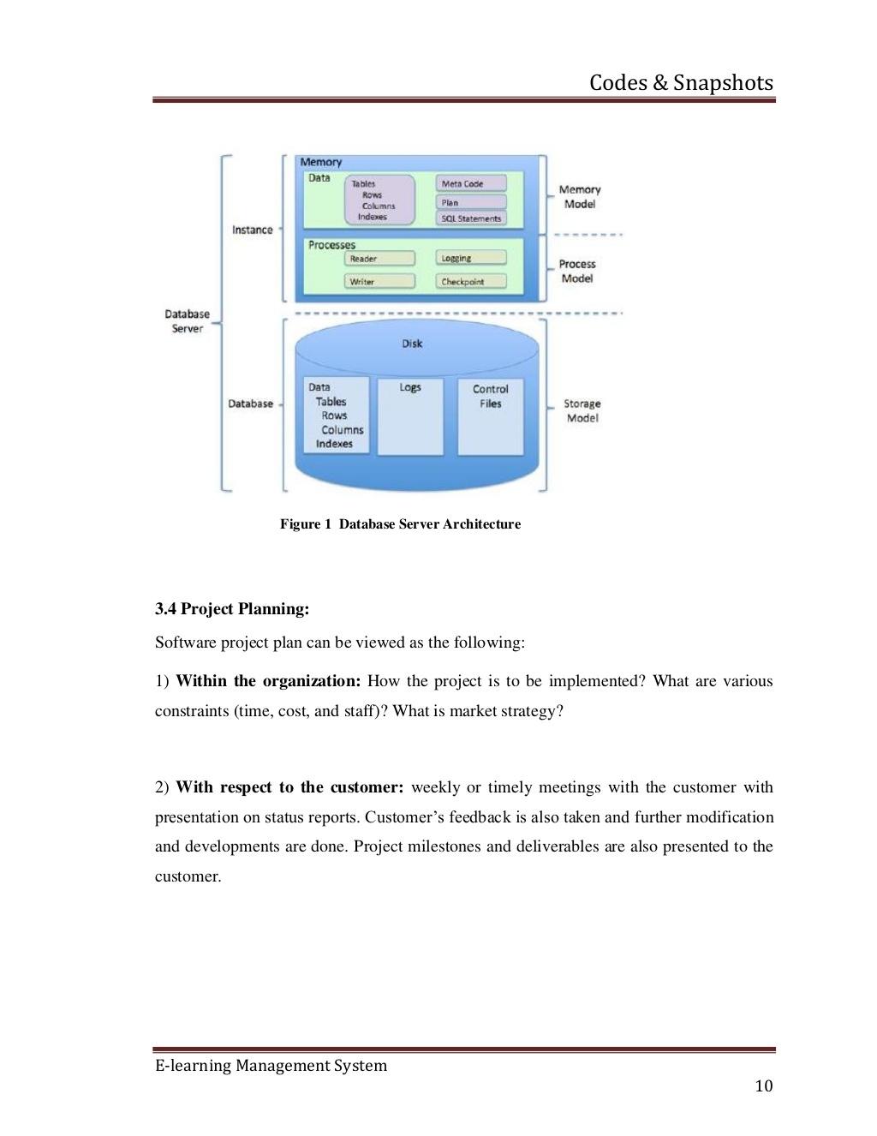

1. Table

A table is a collection of data represented in rows and columns. Each table has a name in database. For example, the following table “STUDENT” stores the information of students in database.

Table: STUDENT

|  |  |  |  |
| --- | --- | --- | --- |
| **Student_Id** | **Student_Name** | **Student_Addr** | **Student_Age** |
| 101 | Chaitanya | Dayal Bagh, Agra | 27 |
| 102 | Ajeet | Delhi | 26 |
| 103 | Rahul | Gurgaon | 24 |
| 104 | Shubham | Chennai | 25 |

2. Record or Tuple

Each row of a table is known as record. It is also known as tuple. For example, the following row is a record that we have taken from the above table.

## Model of The Project:

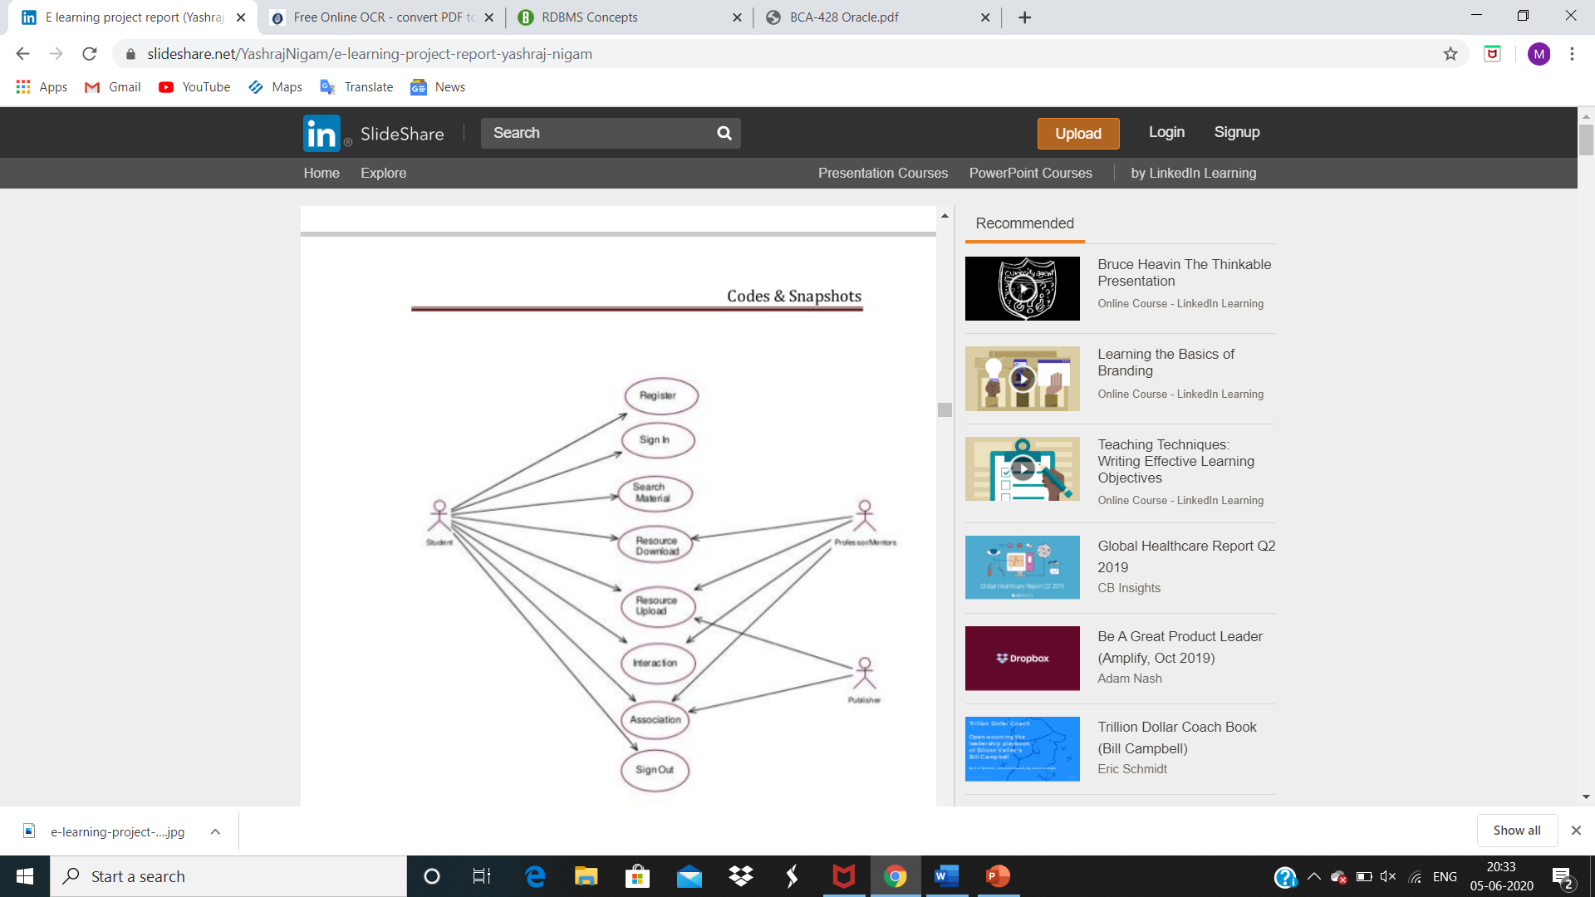

*Entity Relationship Diagram For*

*E-Learning system*

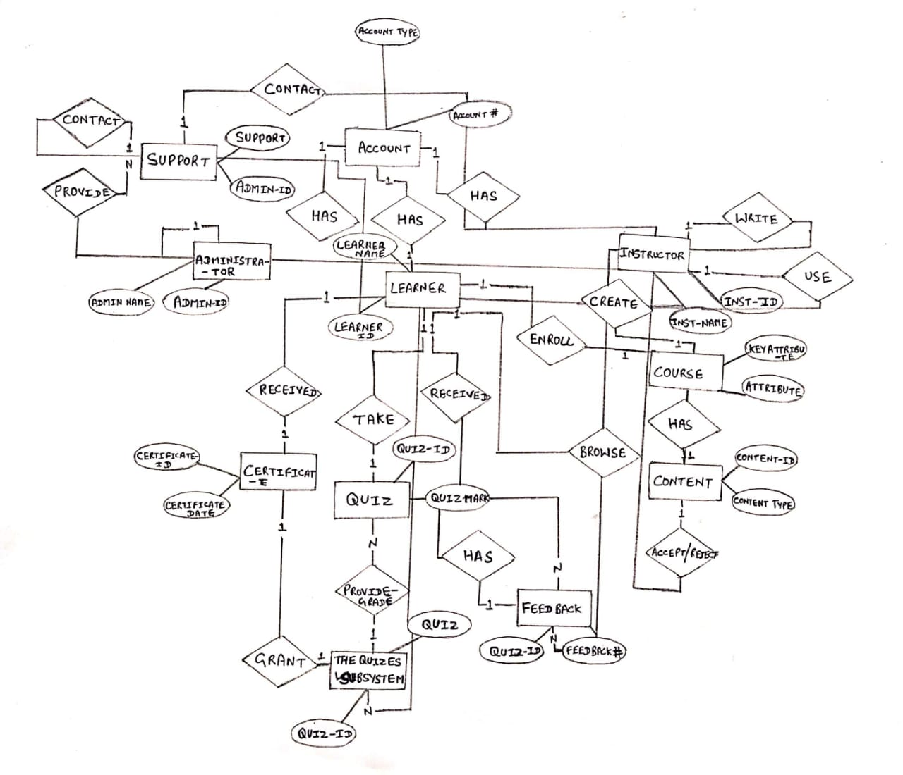

Mapping of ER-Realational Model

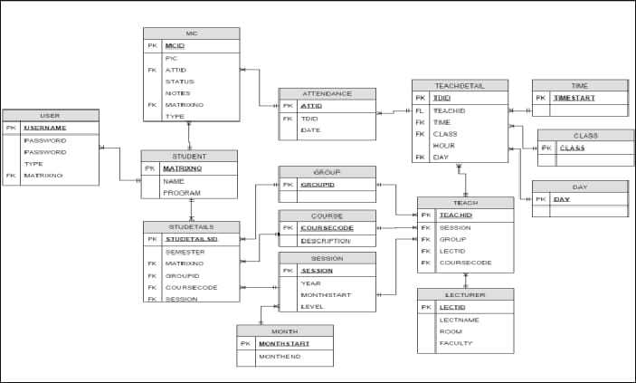

SQL:

Table Creation:





Insert values:

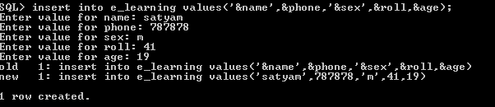

Display any one table details with other table:

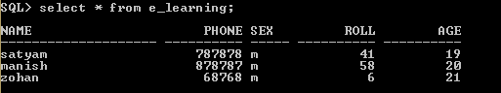

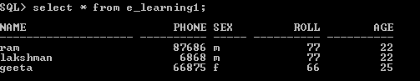

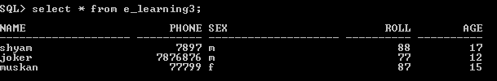

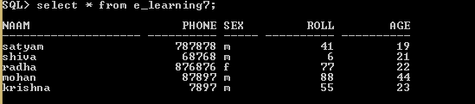

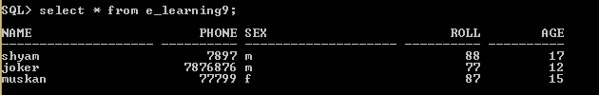

Updating values:



Diplaying update: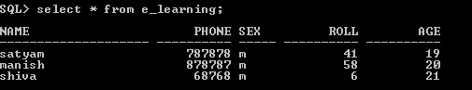

Joining two tables:

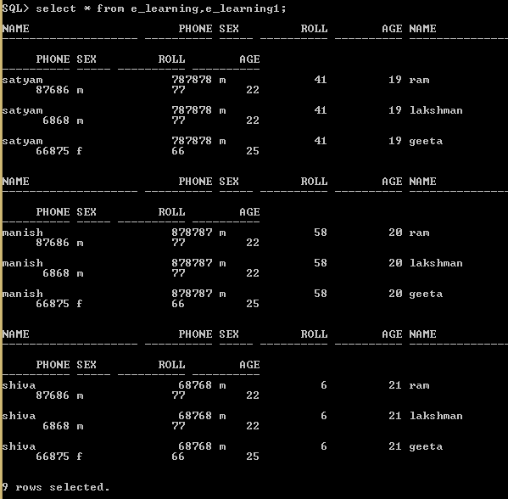

Display max age from the remaining records:

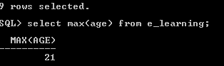

Display the name by removing 3rd,4th ,5th character:

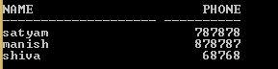

Displaying value:



Rename table:



Rename Field:



Remove particular attribute:

